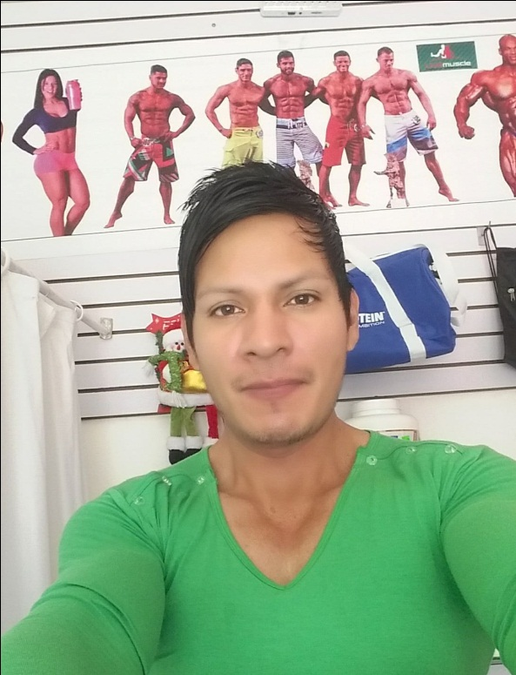

**EDGAR AMILKAR VALLEJOS EVANGELISTA**

**CONTACT**: 977 814 857

**Email:** garyvallejos1@gmail.com

**ADDRESS:** avenue sauces MZ D-3 lot 15 Santa Clara Ate- LIMA PERU

**DRIVER'S LICENSE:** A2B

**EDUCATION:**

D'FITNESS SCHOOL (2024)

fitness dance

DANIEL ALCIDES CARRIÓN INSTITUTE

massage therapy

**DIPLOMA IN MUSCLE HYPERTROPHY SCIENCE (IFBB - 2023)**

CRC – SUPERIOR ENGLISH CENTER

English language

VEDIKA INSTITUTE - VYVE SALUD BARCELONA (SPAIN)

Alternative natural medicine course

IN MOTION FITNESS AND NUTRITION

Sports supplementation and ergogenic

**NATIONAL SPORTS FEDERATION OF BODYBUILDING AND FITNESS PERU**

Gym fitness Instructor (IFBB - 2017)

Personal trainer

ORBE SELECT INSTITUTE OF HUMAN EXCELLENCE (2015)

Human resources management

PERUVIAN WINGS UNIVERSITY

**Management and International Business**

**PROFESSIONAL PROFILE:**

ABOUT ME:

Physical advisor, Certified Fitness Instructor/Personal Trainer, specialized in physical conditioning, bodybuilding and fitness in general

with English language proficiency; passionate about fitness life with six years of work experience in diferents gyms, chains, recreations promoting healthy physical culture. I am ethical, responsible, honest, versatile, loyal and with my own initiative for individual and team work, I like to help and collaborate to meet objectives and goals. Communication at all levels.

**WORK EXPERIENCE:**

**SPORTLIFE FITNESS CLUB (2023-2024)**

COACHES SUPERVISOR

• Manage reports, statistical measurements of weekly performance and train trainers for better service

• Track new partners and maintain (potential clients) impart harmony and regulated facilities

• Lead efficient and effective operations, make decisions, provide general and specific solutions in common.

• Schedule group classes, assign clients with trainers per shift and other administrative support from immediate boss.

**VIP TRAINING GYMNASIUM (2022**)

PERSONAL INSTRUCTOR/TRAINER

• Perform oral physical evaluation tests, anthropometric measurements, design specific training routines

• Sequentially guide the exercises under principles of specificity personalized to all clients

• Lead programmed functional training circuits.

**SILEICA GYM (2021)**

GYM INSTRUCTOR

• Perform an oral physical evaluation test and prescribe training routines according to the specific physical objectives of each client and enforce the general rules of the gym.

• Instruct the correct use of gym machines, equipment, accessories and correct biomechanical executions.

• Promote the fitness lifestyle and general nutrition

**PERFORMANCE FITNESS PERU (2018- MAR2020)**

PERSONAL TRAINER / COACH SUPERVISOR

• Personalize training with different methodologies and systems according to the physical objective of each client.

• Daily physical record of trainers, host, organize, distribute, assign and classify clients to start training

• Control clients and perform physical training tests for those who attend for the first time or promotional guests

**NEWREST PERÚ SAC- CUZCO (2017)**

GYM COACH (REMOTE SITES)

• Promote, encourage well-being through culture and/or physical activity, scheduled active breaks

• Supervise, guide training and create well-being

• Vocational talk according to programming about physical culture and the importance of physical exercises in a recreational gym.

• Teamwork with occupational medicine area for differentiated work and improve work performance, other related support.

**PERFORMANCE FITNESS PERU (2016)**

PERSONAL TRAINER

• Perform oral physical evaluation tests and personalize training for each client.

• Direct individual and/or group functional training

**HOBBIES AND INTERESTS**

Make a career line and always continue learning new experiences un the world

**JOB REFERENCES:**

JOSE ARANA -- CONTRACT ADMINISTRATOR NEWREST PERU SAC (REMOTE SITES) Repsol Nuevo Mundo – CUZCO - 947 041 567

JOSE LUIS CRUZADO-ADMINISTRATOR PERFORMANCE FITNESS PERU SAC 986 948 787

ALDO ZUMAETA – (Sportlife fitness club administrator) 948 709 000