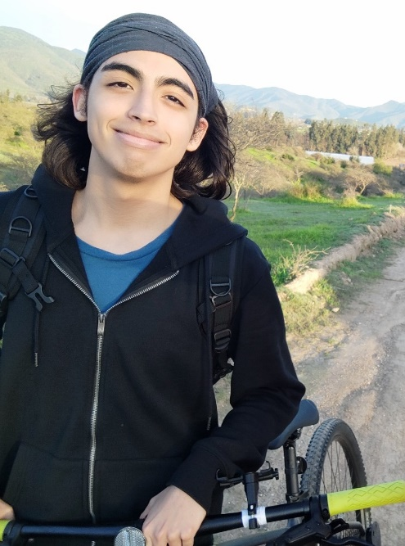

Tomás Andrés Rojas Figueroa

Abbott me:

I possess an English level high enough to make me able to effectively communicate with English speakers, I count with the potential to highlight myself as a competent functionary and I have the right self-evaluation skills to adequately develop in a professional environment.

Personal data:

* Date of birth: 23 July 2005.
* Nationality: Chilean.
* Visa status: Passport valid from February 2024 to February 2034.
* Marital status: Single.

Education:

* Alonso de Ercilla Private School, basic education.
* Colegio San Sebastián de Melipilla, secondary education. Accomplished.

Higher Education:

* Aiep Institute of the Andrés Bello University, Santiago / Advanced 1 (Year 2022)
* Aiep Institute of the Andrés Bello University, Santiago / Advanced 2 (Year 2022)
* Instituto Chileno - Britanico, Santiago, Advanced Higher English Program with passing grade 6.1 (Year 2023)

Work Experience:

* Working in Tricot stores, in reception and sales of clothing and maintenance of the department. (Year 2023) Melipilla.

References:

* José Tomás Figueroa Zúñiga.
* Jefe de Local Melipilla, Tricot.
* Cel: +56990850329
* Mail: Tommyfiguer@gmail.com Languages:
* Spanish - English

Own skills and characteristics:

* Proactive
* Empathetic
* Analytical and reflective
* Bilingual proficiency, fluent Spanish and English

Hobbies:

* Travel, know
* Run
* Listen to music