

|  |  |  |  |  |  |  |  |  |  |  |  |  |  |  |  |  |
| --- | --- | --- | --- | --- | --- | --- | --- | --- | --- | --- | --- | --- | --- | --- | --- | --- |
| |  |  | | --- | --- | |  | Vicente Felipe Vidal Paredes  BARTENDER, WAITER, CLEANING, BARISTA, ROV OPERATOR |  Profile I have worked as a waiter for two years and as a bartender for one year. I received specialized training at the Bartenders School of Chile, where I learned classic cocktail techniques and proper measurements. I also worked in a coffee shop, where I gained some knowledge related to the world of barista work.  For nearly three years, I have also worked as a concierge. I consider myself a proactive person, always willing to learn and help. I respond well to instructions and am fully committed to fulfilling whatever the company requires and needs.  I have a course of OPERATOR ROV too, but without laboral experience  I have English courses in Puerto Montt in One English and Wall Street Institute Laboral ExperienceCook and kitchen assistant, Domino's Pizza, Puerto Montt 2016 — DECEMBER 2016  Throughout 2016, I worked as a **cook and kitchen assistant** at **Domino’s Pizza** . Salesman, Akar, Viña del Mar FEBRUARY 2020 — MARCH 2020  n 2020, I worked as a **sales representative for cleaning products** . Unfortunately, I was only able to continue for a few months, as the company was forced to close due to the pandemic and the public health regulations in place that year. Waiter and Bartender, Barrabass Rock&Roll Bar, Puerto Montt FEBRUARY 2021 — OCTOBER 2023  I have two years of experience as a **Restaurant Server** , and one year as a **Bartender** , with formal training in classic cocktail preparation. Concierge , Jardines de Altomar & Terramar Condominiums, Puerto Montt MARCH 2023 — MAY 2025  Since 2023 and continuing into the present, I have worked as a **concierge** at two residential condominiums, handling a wide range of shifts, including both **full-time and part-time schedules** . Barista, Café Rotunda, Puerto Montt FEBRUARY 2024 — APRIL 2024  For a few months, I worked as a **temporary replacement at Café Rotunda** , where I served as a **waiter** and also gained some **basic experience in barista skills** . Education Completed Secondary Education in 2014 |  | Details Marital Status: Single  Nationality; Chilean/Polish  Adress, Upper Drumcondra Road/Griffith Avenue, Drumcondra, Dublin 9  Telephone Number:  +353 89 218 0832  [vicefelip@gmail.com](mailto:vicefelip@gmail.com) Language  |  |  | | --- | --- | | Spanish | | |  |  |  |  |  | | --- | --- | | English | | |  |  |  |  |  | | --- | --- | | German | | |  |  | |

Degree:

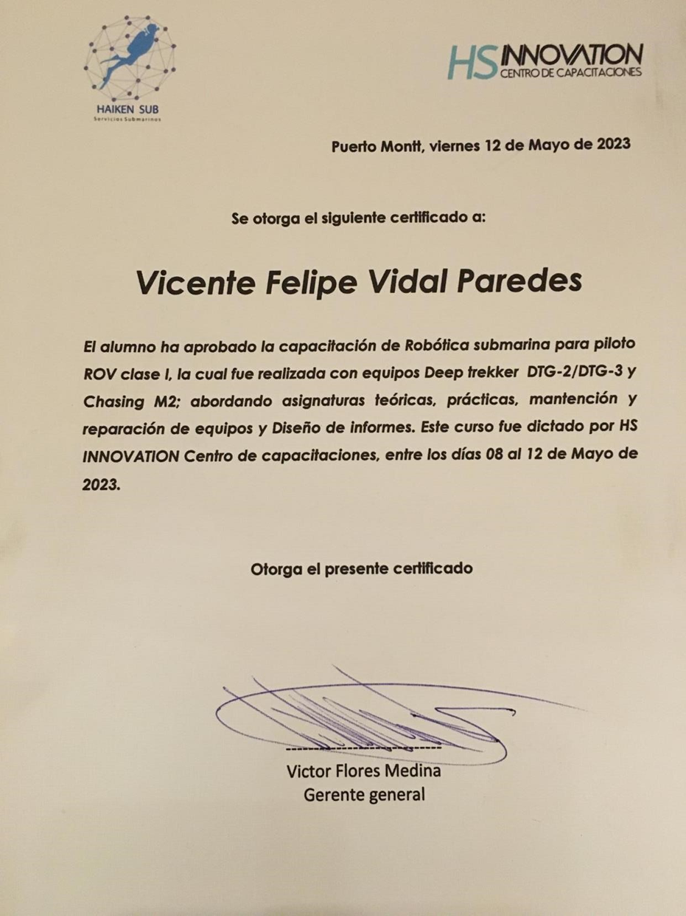

Degree:

