Mishel Ibañez Orihuela

Bolivian, February 22, 1996, Single Woman, No# Children: 0 Children
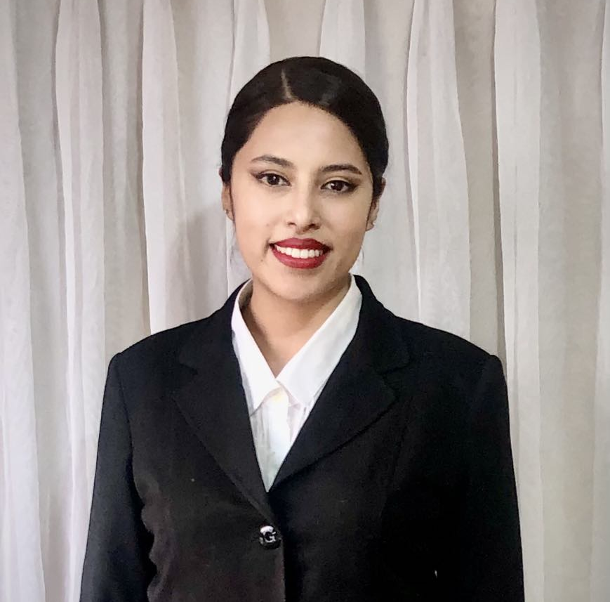
Pampahasi, La Paz City, Bolivia
mishelibanez@gmail.com, Cell Phone: +591 69979121, https://join.skype.com/invite/eq0B1fv48KR7

Education

(March/2015) to (May/2022): Federal University of Latin American Integration
Biological Sciences / Degree obtained
Av. Tarquínio Joslin dos Santos, 1000, Brazil (https://portal.unila.edu.br/)

(October/2022) to (December/2024): University of Sao Paulo
Master of Business Administration (MBA) in Project Management / Degree obtained
(https://www5.usp.br/)

Work Experience

(June/2024) to present
Atix Boutique Hotel, La Paz, Bolivia
(https://atixhotel.com/es/)
Bar waitress: Five Star Hotel. Experienced as a bar waitress, demonstrated skills in delivering exceptional customer service and ensuring a welcoming dining experience. Excelled in high-pressure team environments while maintaining high standards of customer service.

(January/2023) to (July/2023)
VIDA Assisted Reproduction Center, La Paz, Bolivia
Receptionist / Assistant: Provided exceptional and professional customer service, ensuring a welcoming atmosphere for clients. Offered attentive and discreet support to patients, assisting with inquiries, appointment scheduling, and general administrative tasks. Demonstrated empathy and professionalism in a sensitive and confidential environment, helping to create a positive experience for all visitors

(December/2021) to (December/2022)
Hotel Mabu Thermas Grand Resort, Foz de Iguazú, Brazil (https://www.hoteismabu.com.br/hoteis/mabu-thermas-grand-resort-foz-do-iguacu)
Waiter and Restaurant Supervisor: Five Star, high volume hotel Resort. Directed daily operations, ensuring an exceptional guest experience. Oversaw staff performance, conducted training sessions, and maintained strict adherence to quality standards and operational protocols. Ensured the restaurant's cleanliness, organization, and ambiance consistently met luxury standards. Successfully managed team dynamics in a fast-paced environment, fostering collaboration and achieving director satisfaction.

(March/2021) to (May/2021)
Dreams Eco Park, Foz de Iguazú, Brazil
(https://dreamsparkshow.com.br/falcoaria-em-foz-do-iguacu-pr/)
Intern - Customer Service: Tourism Company with a high volume of receiving tourists in the region. Support the daily activities of the Center. Reception and attention of visitors. Maintenance and cleaning of the center.

Seminars, Trainings & Courses

(November/2010) to (February/2011): Public speaking and etiquette course

Languages

Language: Fluent in written and spoken English, Portuguese and Spanish (Native).

Computer Skills

Microsoft Office suite, Google suite (Meet, Drive, Documents Google, Spreadsheets, Presentations, Hangouts), Light room, Shot cut, Skype, Chat Gpt.

Certifications

Portuguese language proficiency test – CELPEBRAS

