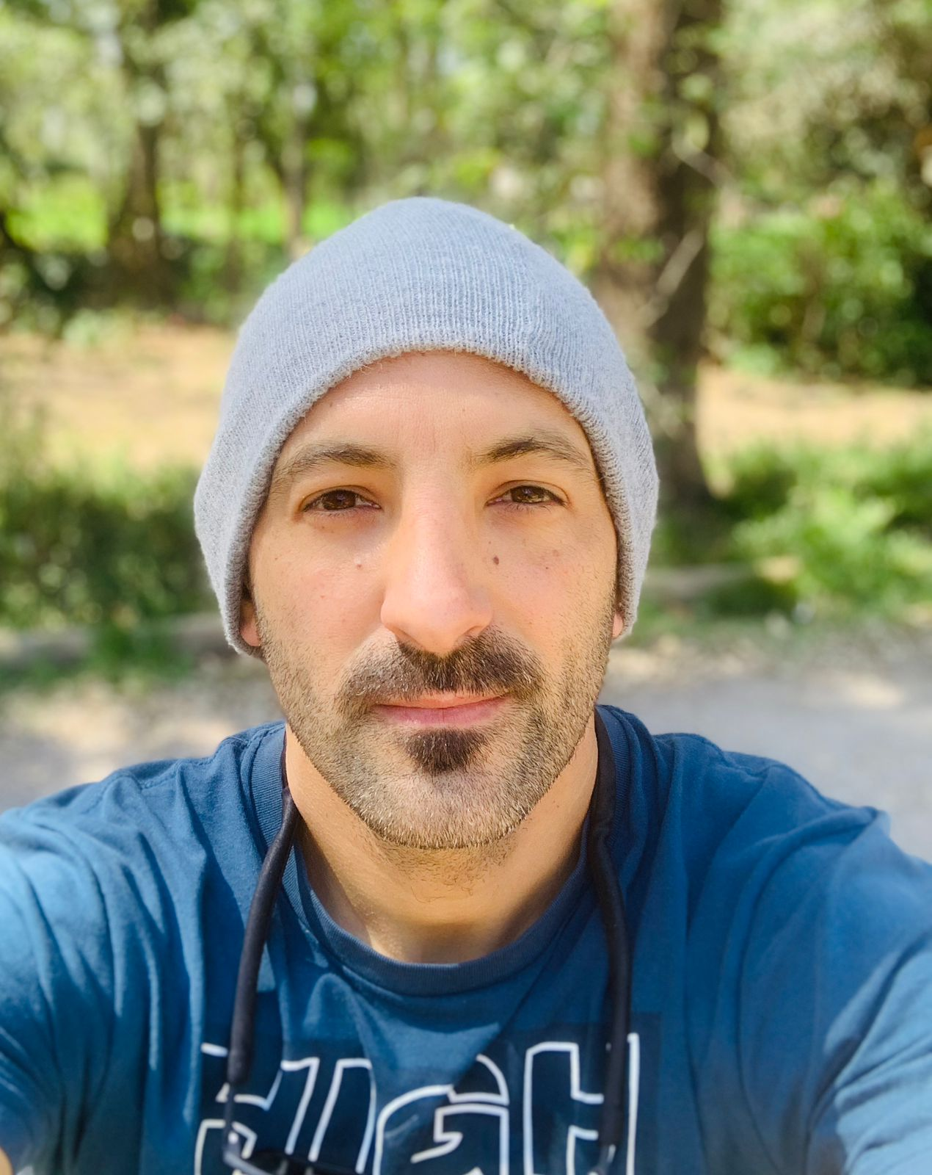

*Contact:*

Cell. 11-69153794

[**marianopiacenza@gmail.com**](mailto:marianopiacenza@hotmail.com)

Mariano Piacenza (44 years old)

|  |  |  |  |
| --- | --- | --- | --- |
| **Work Experience**    **Education** | Los Glaciers National Park 2022/25  **Licensed tourist guide**    Educational institutions Secondary level  **Physical education and tourist information teacher**  Huka and Andean center bsas  **Coordination of educational camps**  **“**University Institute of the Argentine Federal Police”.  **University Professor, Secretary of University Extension**  “Hotel kau-yatun” - El Calafate Sta Cruz  **Front desk**    “Calafate Park Plaza” - El Calafate Santa Cruz  **Front desk**  "Don Quijote" - El Calafate Santa Cruz  **Front desk**  “Alice farm”- El Calafate Santa Cruz  **Waiter**  “Gala tour”- Bsas 2002-03  **Travel coordination**   |  |  | | --- | --- | |  | TITLE: **National Professor of Physical Education**  José Ingenieros- OSN – CABA  TITLE: **Higher Technician in Mountain Guiding**  Andean Center Buenos Aires  TITLE: **Lifeguard**  Esc Gob of the city of bsas  TITLE : **Higher Technician in Tourist Guide**  ISFT No. 173 - Bs.As.  TITLE: **Technological Baccalaureate with a focus on the Environment**  UNLA - Technological Baccalaureate | |
| **Courses** | * *School of languages ( Portuguese – English )* * *Popular Economy and Comprehensive and Inclusive Solid Waste Management* * *Courses in English and Portuguese* * *First aid in wild environments* * *Seminars and conferences on sustainable tourism* |
|  |  |