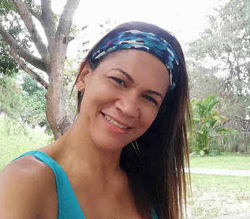

**RAIZA ISABEL CARABALLO**

Certified Personal Trainer 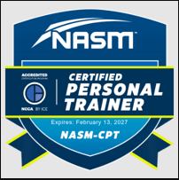

**PROFILE**

Motivated and results-oriented Certified Personal Trainer with extensive experience in various fitness settings. Passionate about designing personalized fitness programs that empower clients to achieve their health and wellness goals. Skilled in postural and dynamic control training, core and balance strengthening, and stability and strength exercises. Strong background in spinal health, with expertise in developing structured programs like the CR Forte program, a mesocycle designed to preserve and restore spinal health. Excellent communicator and motivational leader, with a proven track record in delivering client-centered results and creating engaging fitness initiatives.

**CERTIFICATIONS**

* **Certified Personal Trainer (CPT)**  
  National Academy of Sports Medicine (NASM) – Gilbert, AZ  
  *Issued: February 2025*  
  [https://credentials.nasm.org/97ee1606-088b-4b25-8ca1-e38e09937f15#acc.sGfWhlzD]
* **CPR/AED (Adult, Child, Infant)**  
  American Safety Training Institute (ASTI)  
  *Issued: January, 2025*  
  [blob:https://portal.nasm.org/73dc855c-ef55-4ed2-b98a-3fefa82cfae0]
* **Certificación Internacional Pilates Serie 34**  
  Centro Holístico A-Balance – Envigado, Colombia  
  *Issued: November 2021*  
  [https://drive.google.com/file/d/1kmBkBV60-kmK6nDusAbtRlwN8wd1C2Z4/view?usp=drive_link]
* **Certificación Experto en Motricidad Humana**  
  Federación Española de Actividades Dirigidas y Fitness (FEDA) – Madrid, España  
  *Issued: March 2021*  
  [https://drive.google.com/file/d/1ZpvmoNdgMe4vRu5Uunb5vb266Kc2TjVj/view?usp=drive_link]

**EXPERIENCE**

**Group Fitness Trainer**  
*Hoover Veteran Park, Birmingham, AL*  
*January, 2022 – Present*

* Developed and led dynamic group fitness sessions designed for total body conditioning, focusing on functional movement patterns and strength training.
* Conducted strength training, resistance exercises, and core workouts to improve overall fitness and endurance for diverse client groups.
* Led group fitness classes with a focus on accessibility, ensuring exercises were appropriate for all fitness levels.

**Aqua Fitness Instructor**  
*Samambaya House Club, Caracas, Venezuela*  
*October 2022 – November 2023*

* Specialized in providing low-impact aquatic fitness training for senior citizens, improving their flexibility, balance, and overall fitness levels.
* Conducted detailed fitness assessments to identify physical limitations and create tailored fitness plans.
* Collaborated with club owners to develop and introduce engaging and innovative aquatic fitness programs.

**Group Fitness Trainer**  
*Polideportivo Manzanares, Caracas, Venezuela*  
*August 2018 – November 2023*

* Successfully guided a group of 40 clients, many of whom had no prior exercise experience, through their fitness journey, achieving measurable improvements in strength, mobility, and mental well-being.
* Delivered personalized fitness assessments to evaluate each client’s fitness level, health history, and goals.
* Developed individualized training plans with a focus on spine health, corrective exercises, and core strengthening.
* Led group and one-on-one training sessions, fostering a positive and motivating environment that promoted consistency and long-term results.
* **Availability**: 30 Days
* **Willingness to relocate**: Yes
* **References available upon request**