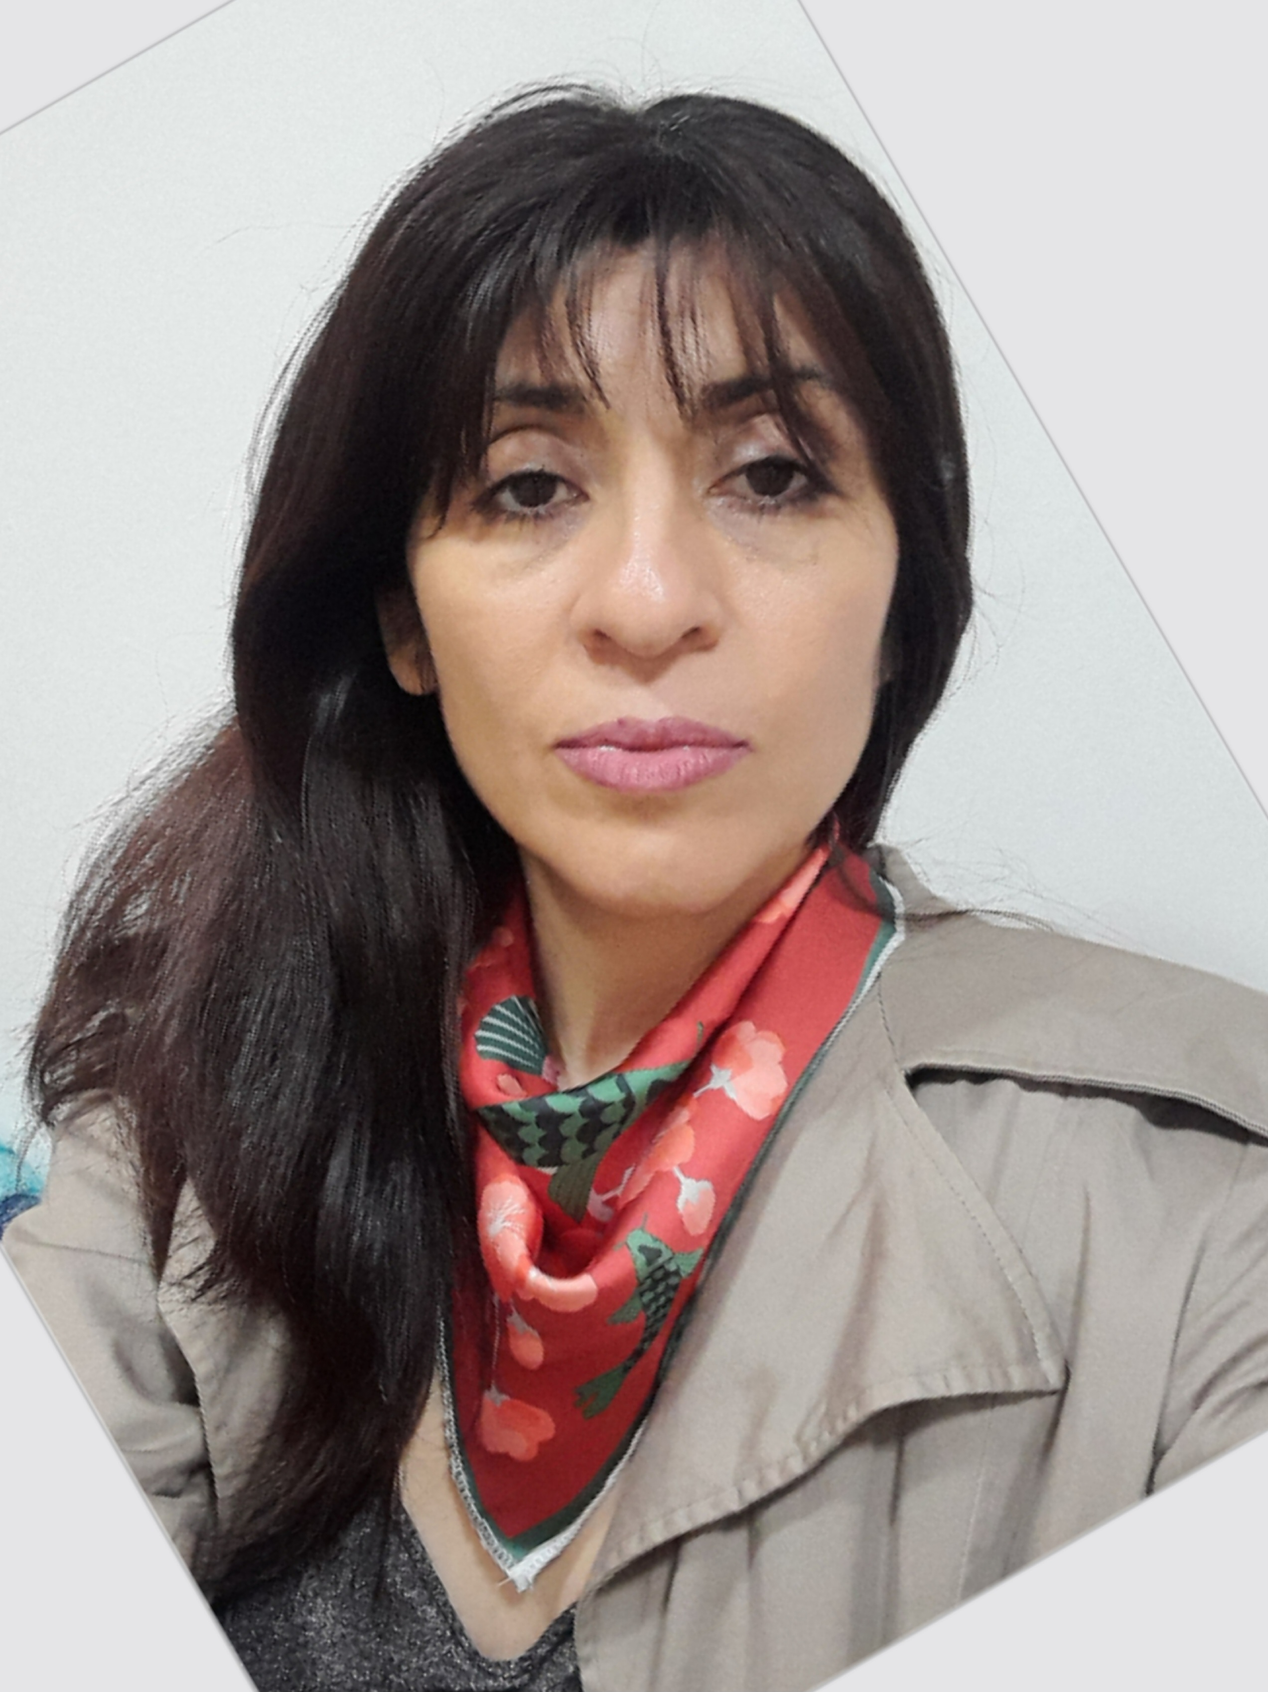 |  | DANIELA AZUCENA LUNA
frofile  Registered Nurse with more tan 20 years of experience in Neonatal, Pediatric and Adult care. In search of new work challenges.  contact  Cell pone: +54 2262650274  E-mail: lunadana264@gmail.com  Professional registration: 238778 (Buenos Aires province)  LANGUAGES  English, intermediate |  | education  -Degree in Nursing (2016-2017)  Universidad Maimónides, Necochea headquarters  -University Nurse, Universidad Nacional de Quilmes, Necochea headquarters (1997-1999)  work experience  Municipal Hospital of Necochea Emilio Ferreyra  From 2000 to 2024: Care nurse in áreas of Pediatric and Adult Emergency: hospitalization of: medical clinic, surgery and traumatology, pediatrics, maternity and neonatology.  main skills  Decisión making, willigness to acquire new knowledge, ability to work as a team.  courses  - Neonatal CPR, Dr Espelet  - Neonatal Respiratory Pathologies, UBA  -STCW bordin card

