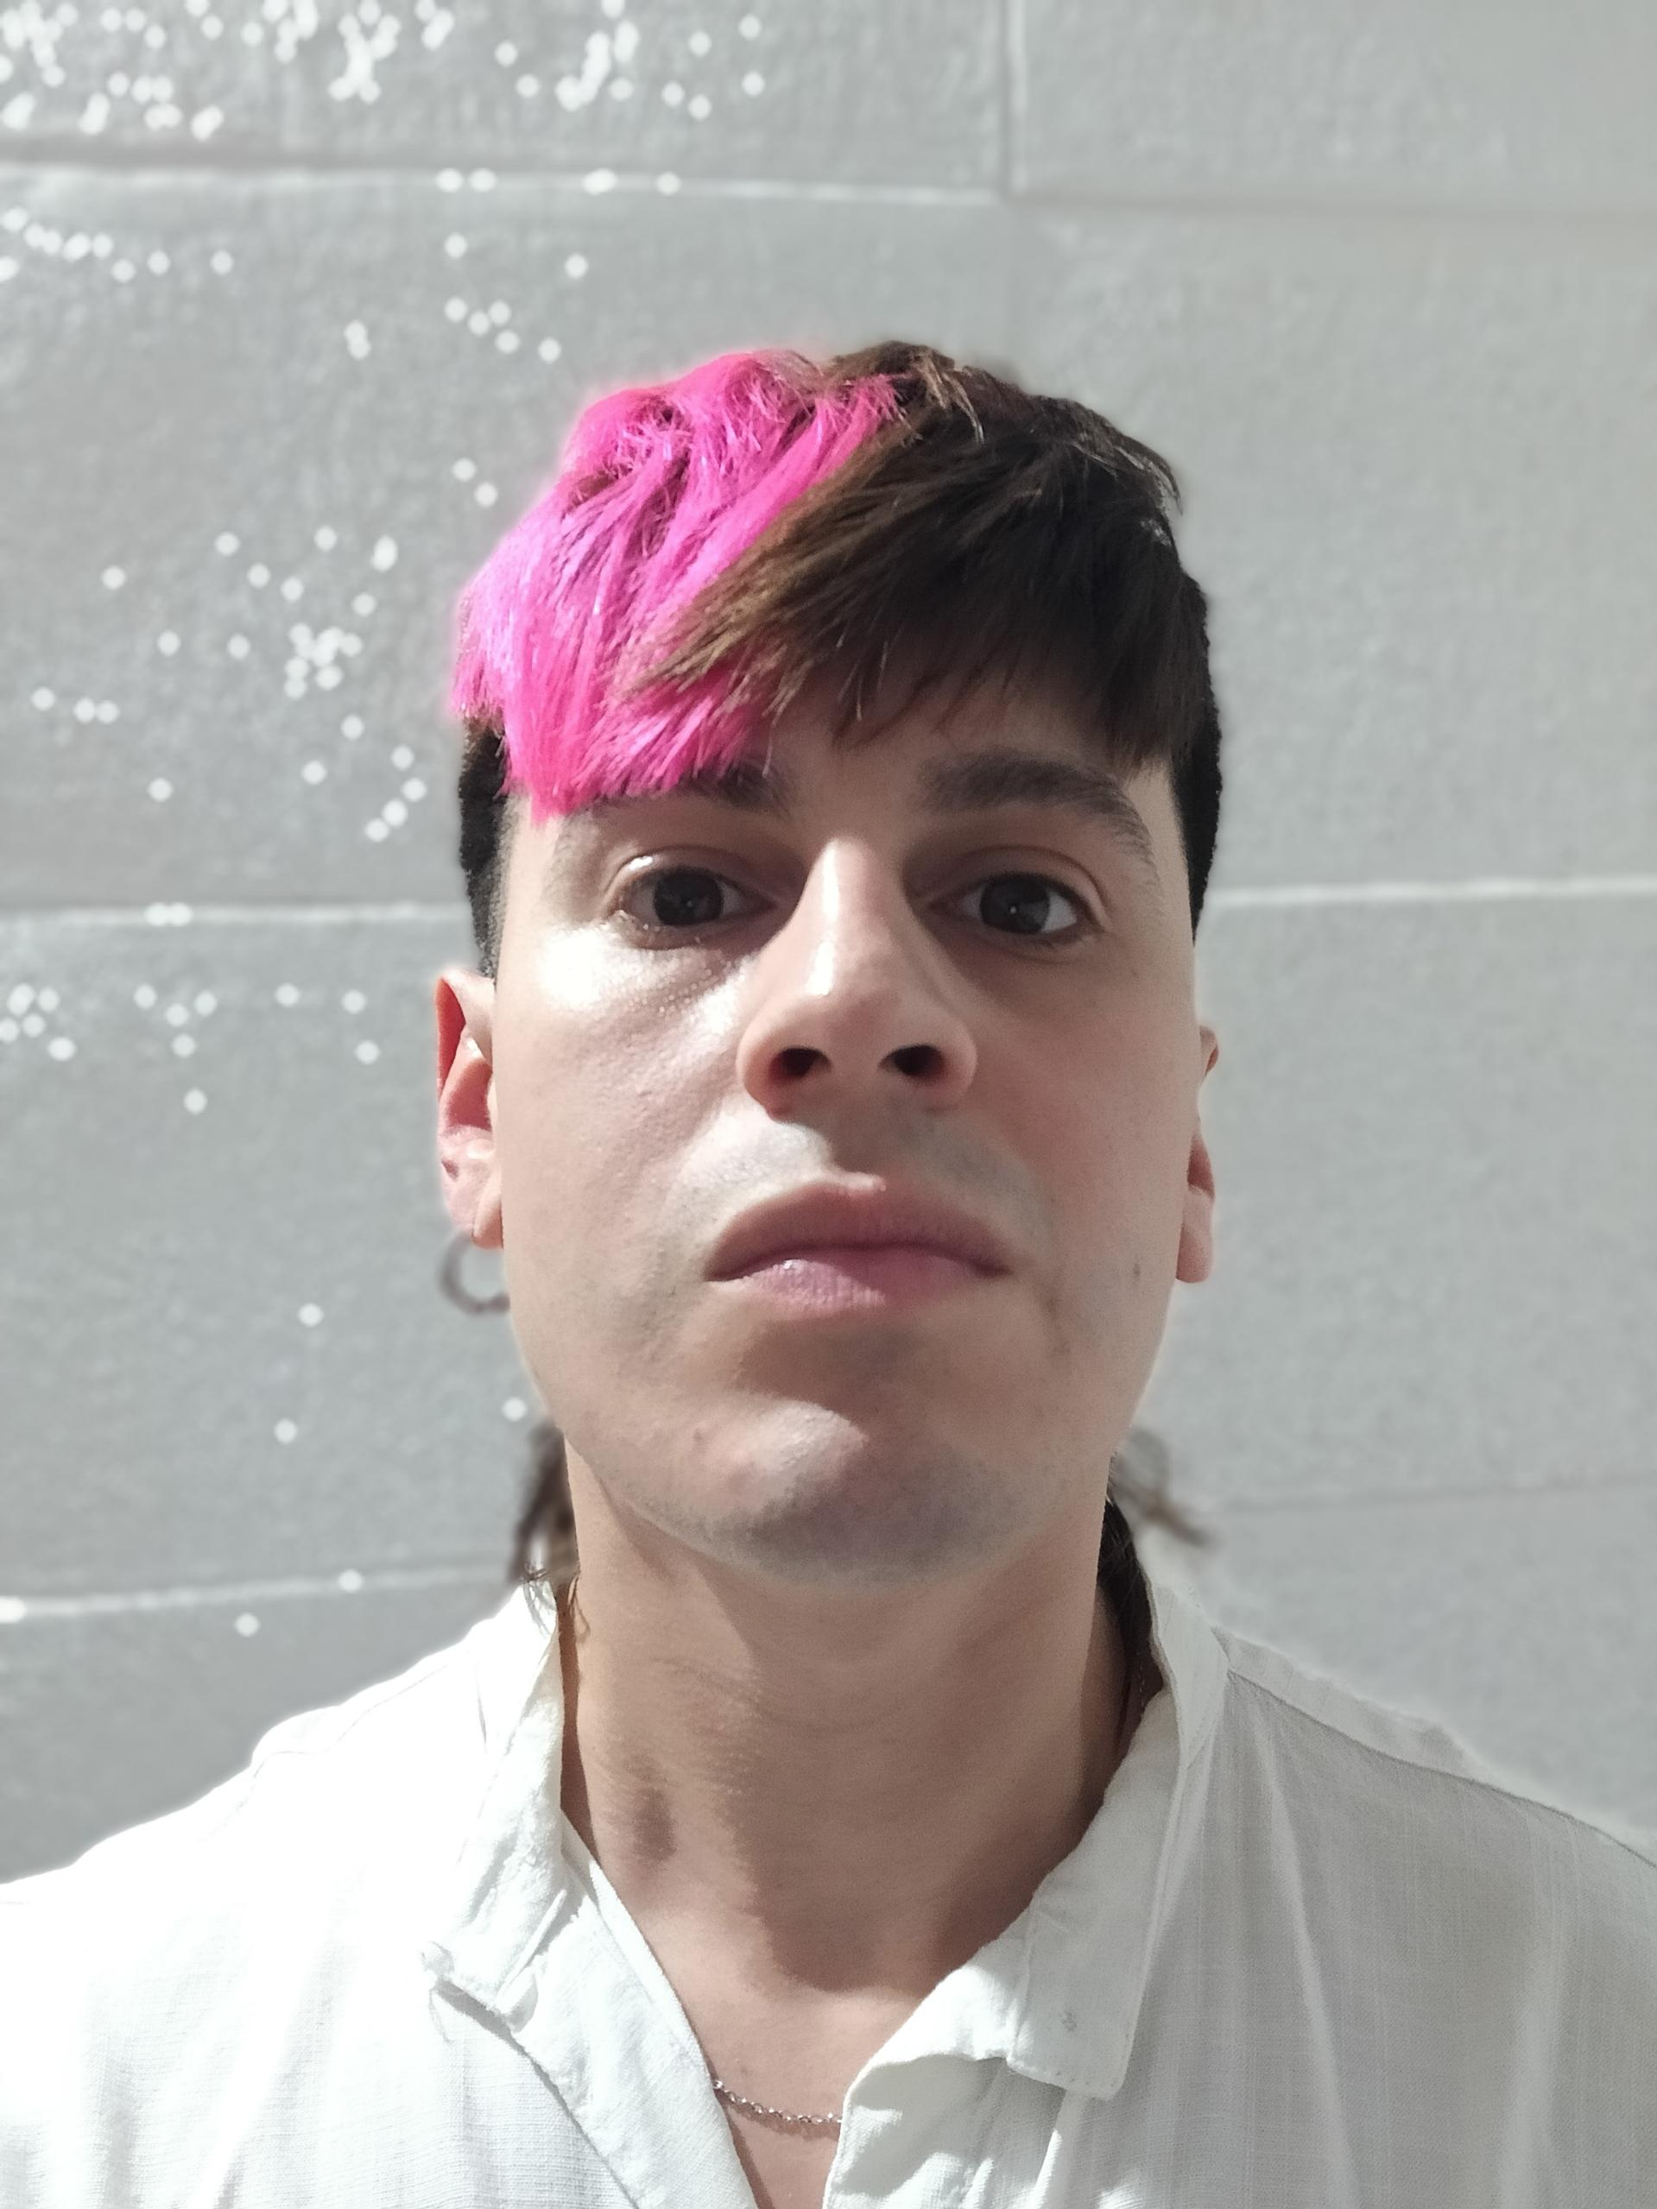­

2021 - Present

WORK EXPERIENCE

**Hairdress** – Diego Calla Estudio



Hairdresser with over 4 years of experience in haircuts, coloring and hair treatments . Focused on giving great service and personalized advice. Always looking to learn new techniques and improve to offer the best to clients.

Passionate about  the latest trends and new ways of working in the industry

**Creator of DIEGO CALLA ESTUDIO**

DIEGO CALLA ESTUDIO

+54 1135714700

2018 – 2019

**Hairdress** – Maison Matias Estilistas

* Assistant
* Men’s and women’s haircuts
* Customer service and advice: Providing a personalized experience, recommending styles, haircuts, and treatments based on each client’s needs.
* Assistant: Supporting some tasks in the salon, from preparing materials to assisting in procedures.
* Men’s and women’s haircuts: Skilled in different cutting techniques to suit some styles and trends.
* Hair treatments: Applying products and treatments to maintain and improve hair health.
* Cash register management: Handling payments, processing transactions, and managing the salon’s cash flow.
* Opening and closing the salon: Organizing the workspace, preparing the work area, and securely closing the salon.
* Salon cleaning: Keeping the space clean and tidy to ensure a better experience for clients.
* Spanish: Native speaker
* English: Fluent level

Facundo Cuellar

**Hairdresser**

©AZURIUS – Modelos-de-curriculum.com

Diego Calla

EDUCATION

2017 – 2018

**Unisex Hairstylist** – ACP San Miguel

**Mechanical Technician** – High School

2009 - 2015

REFERENCES

OBJECTIVE

* Proactive
* Helpful
* Teamwork skills

SKILLS

LANGUAGES

Buenos Aires, Argentina

facundom.cuellar@gmail.com

f

+54 1126161974

©AZURIUS – Modeles-de-cv,com