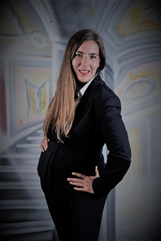 |  | Marina Saboulard  Sailor. Stewardess. Receptionist.  Located in Sarasota, FLORIDA  Available ASAP
Profile  I'm well-rounded, organized and hardworking team player. I'm not afraid of long hours and hard work. Attention to details is important for me in my job.  I adapt very easily to any working environment and I'm more than happy to rotate in all departments.  Relevant skills  - Extensive life experience on board.  - Active team player.  - Quality customer service.  - Wide experience in hospitality.  - Experience in animal care and dog training.  - Experience in sales.  - Fluent English- Portuguese- Spanish.  - Basic Italian- French.  - Professional photographer.  Contact  USA +1-9049142024  ARG +549-1155739701  EMAIL: marinasaboulard@gmail.com  IPM EVALUATION AND REFERENCES AVAILABLE UPON REQUEST |  | Work experience  MSC Cruises  Photographer  Miami- Caribbean. Season 2021-2023  Lagoon 52 Cat “White Rose”  Stewardess  Charter Caribbean. Season 2021  Velero El Rocinante  Stewardess. Deckhand. Tour guide.  Day charter. Argentina. Uruguay. Season 2021  Isadora Women’s accessories  Seller retail. Sales strategies. Logistics  Buenos Aires Argentina. 2019-2021  GeMoney General Electric  Sales promoter. Hunter  Buenos Aires Argentina. 2018-2019  Hotel Madero 5*  Hotel receptionist – front desk  Buenos Aires Argentina. 2015-2017  Licenses and certificates  STCW (IMO 3.27/1.20/1.21/1.13/1.19)  Crowd management (IMO 1.28)  - Sailor Steward Rating Silver service (IMO l/1-1.13)  Argentine Passport (EU in process)  Panama Seaman book  USA Visa B1/B2 and Visa C1/D  Fully vaccinated + booster  Medical update

