***Martín Adrián Rossi***

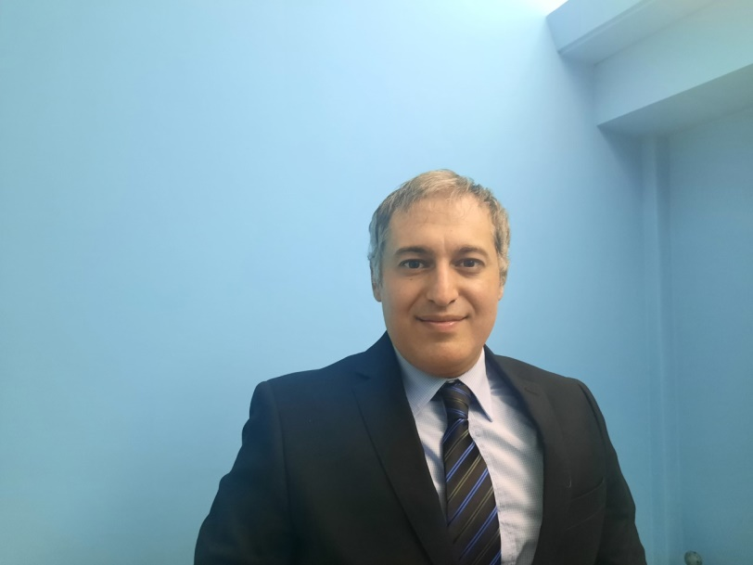**Mobil Phone:** 1560128373

**E-mail**: [martin_rossi83@hotmail.com](mailto:martin_rossi83@hotmail.com)

**ID:** 30.182.114

**Born**: 11 March, 1983

**Civil status:** Single

**Nationality**: Argentinean

**Adress**: 3777 Honduras st, Buenos Aires, Argentina

|  |  |
| --- | --- |
| Professional  Objetive | *I want to work with passion being part of the staff with such a high level of prestige your company has earned. As for me, I would be highly motivated to develop my skills and grow professionally.* |
| Academics | ***Cabin Crew***  ***Airnavigators professional school***  *Graduate in August 2014 (220 hs).*  ***Hospitality management***  ***Argentinean John F. Kennedy University***  *Graduate in May 2008.*  *Grade carrear, (four years)* |
| Languages | * ***English:*** *Advance, written, spoken, listened and read. Currently studying at* ***Wall Street English.*** * ***Portugues****: Intermediate* * ***Italian****: Beginner, currently studying at* ***Language University Center*** * ***French****: Beginner, currently studying at* ***Language University Center*** * ***Spanish****: Native* |
| Professional  Experience | ***Sheraton Retiro and Convention Center***  ***Waiter***  *2004 -2005*  ***Pestana Buenos Aires Hotel***  ***Bell boy, Telephone Operator***  *2005-2009*  ***Booking assistant***  *2009-2011*  ***Receptionist and Night Audit***  *2011-2015*  ***Front Desk Agent***  *2015-Current*  Performing the following tasks: Direct and phone assistance, taking reservations, rooms assignment, check-ins, providing direct assistance to our guests, Check-outs, Cashier, Communication with other areas. Ensure our guests spend memorable moments. |
| Hobbies | *Tennis, Swim, Run, Gym, Draw, Digital Design, Film, Music, Travel* |