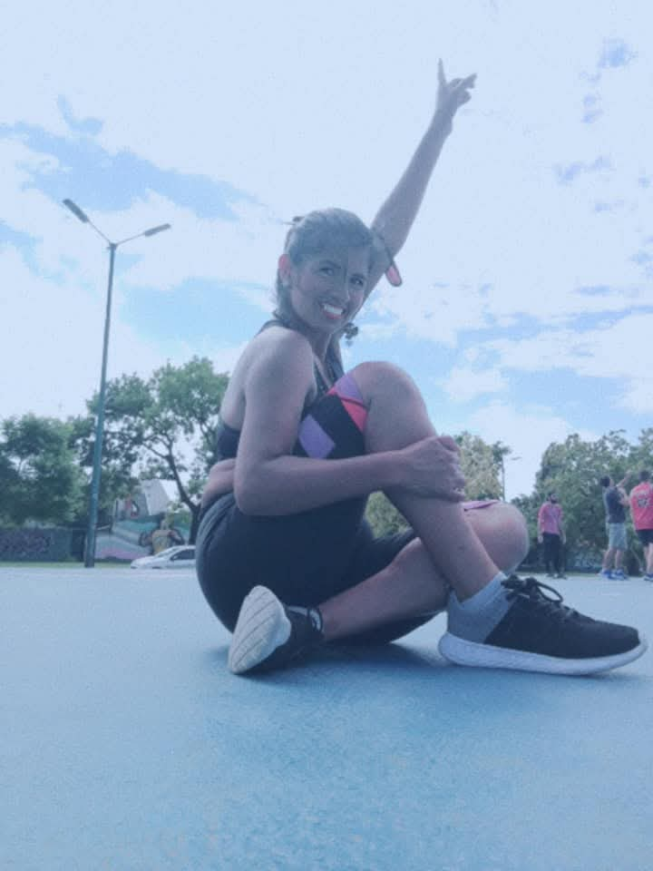

VIOLETA SOFIA VERASTEGUI

FITNESS INSTRUCTOR

Profile
Phone: 1143710919
Mobile: 1528603802
ID: 93759942 | CUIL: 27-93759942-6
Email: viole.sofia@gmail.com
Address: Uruguay 251, Capital Federal, ZIP – 1015
Social Media: Instagram and Facebook @violetaverastegui
Creator of the campaign “Discover Your Strong Version”, a project where I offer and spread Strong Nation, whether in parks, sports centers, or clubs. I believe that sharing with others a form of entertainment, whether dance or exercise discipline, goes beyond earning money. The message is that we can connect with our best mental, emotional, and physical version through healthy habits like nutrition, meditation, grounding, sunbathing, or being in nature. This is vital for discovering an improved version of ourselves.
I am an active member with benefits; licensed to teach STRONG Nation classes:
- One-hour classes full of music and movement
- New routines every month + exclusive music
- Progressions and modifications (low, basic, and max intensity)
- Music + warm-up routines
- Music + cool-down routines
- Listed classes at STRONGNation.com
- Personal STRONG Nation coaching
- Guidelines and alignment: student care to prevent injuries
I’m a Latin Rhythms Dancer — salsa, merengue, and hip-hop. I’m passionate about dance and see it as a form of communication and a tool to boost self-esteem and vibrational energy through life’s journey. I am a student of self-discovery and constant personal development. I practice meditation and training as a lifestyle and am deeply grateful for this gift.

EDUCATION
Primary: “Normal No. 5015” School
Secondary: “Heroínas Las Toledo” School (Educational centers located in Lima)
Tertiary: 1st year of Dance and Body Expression Teaching Program (Dance School of Bahía Blanca)
University: Law at UBA (currently paused)
Currently: Attending an Intermediate English Conversational Workshop called 'Let’s Start Talking', hosted by a Christian church — includes conversations and reading with native speakers

ART & DANCE STUDIES – FLORES
Jul–Dec 2022: Reggaeton Instructor Program
Urban Fusion Styles Classes
Jul 15, 2023: STRONG Nation Certification
Currently: Member of SYNC Zumba & Community
May 2025: Certified Strong Nation Coach with Weights
Jul–Dec 2023: Reggaeton Fitness Instructor
Jul–Dec 2023: Latin Rhythms Instructor
Credentials & Certificates issued by Setten Academy (Dance & Fitness Training Academy)
CPR (22/08/24): Organized by OSDE and SportClub – Save lives with your hands

WORK EXPERIENCE
IAS – Institute of Healthy Activities, Ayacucho 1264 (CABA)
Group Fitness Instructor, Indoor Cycling — Currently employed since Feb 2024
American Sports, Av. Hipolito Yrigoyen 4321 (CABA)
Indoor Cycling Instructor — Currently employed since 01/03/2025
VILOSGYM, Juan Carlos Cruz 1175 (Vte. Lopez)
STRONG Nation Head Instructor (01/07 to 01/10/2024)
REDFIT, Av. Francisco Beiro 5480 (Villa Devoto)
STRONG Nation Head Instructor (01/09 to 30/12/2024)
“Discover Your Strong Version” Campaign, Plazas Barrancas de Belgrano
STRONG Nation Instructor (01/10/24 to 01/03/2025) with own student group

SKILLS
I have strong group management and guidance abilities, whether for large or small groups — always leading exercises with precision and striving for excellence in every class. I inspire participants to give their best and have fun while getting in shape.
I am passionate about what I do and deeply committed to helping my students discover their improved selves through entertainment. I have experience and the ability to motivate and guide them using original techniques backed by the certified programs I’ve completed.
Currently: Attending an Intermediate English Conversational Workshop called 'Let’s Start Talking', hosted by a Christian church — conversations and reading with native speakers.
I consider myself a responsible person committed to continuous learning and to my students, giving 100% in each class. I recognize that each person is unique and that their reasons for training can vary — therapy, health, physical goals, etc. I support them with that in mind, adding my own fun and personal touch.
Career Expectations: To work in a harmonious professional environment where I can contribute and serve from my authentic self, with professionalism.

